
DOWN DATE ENDORSEMENT- LOAN POLICY (T-3)

ISSUED BY

WFG National Title Insurance Company

File No.:

Attached to and made a part of WFG National Title Insurance Company Loan Policy No. , this day of , 20 .

  - Exception No. ___ of Schedule B and the Pending Disbursement Clause in said policy are hereby deleted.

  - Said policy is hereby amended so that its coverage as to all loss or damage against mechanics’ and materialmen’s liens shall relate to the date of this Endorsement instead of the date of said policy.

  - No survey coverage requested.

[or]

The Company affirms the amendment of the exception as to area and boundaries of the above numbered policy, such amendment to be effective as of the date of this Endorsement.

[or[

Exception as to area and boundaries of the above numbered policy is hereby eliminated save and except any shortages in the area.

[And in the event a review of the survey shows additional matters to be excepted from coverage]

The following exceptions are added to Schedule B of the policy [List specific exceptions regarding matters shown by the survey]:

  - T-19 not requested.

[or]

[T-19 Endorsement previously issued]

The Company affirms the coverage provided in the T-19 Endorsement issued in connection with the above numbered policy, such coverage to be effective as of the date of this Endorsement.
[The following subparagraph(s) of this endorsement are deleted: _________]

[or]

[T-19 Endorsement NOT previously issued]

T-19 Endorsement in the form attached hereto is made a part of the above numbered policy.

[The following subparagraph(s) of this endorsement are deleted: _________]

Nothing herein contained shall be construed as extending or changing the effective date of the aforesaid policy or interim construction binder, unless otherwise expressly stated.

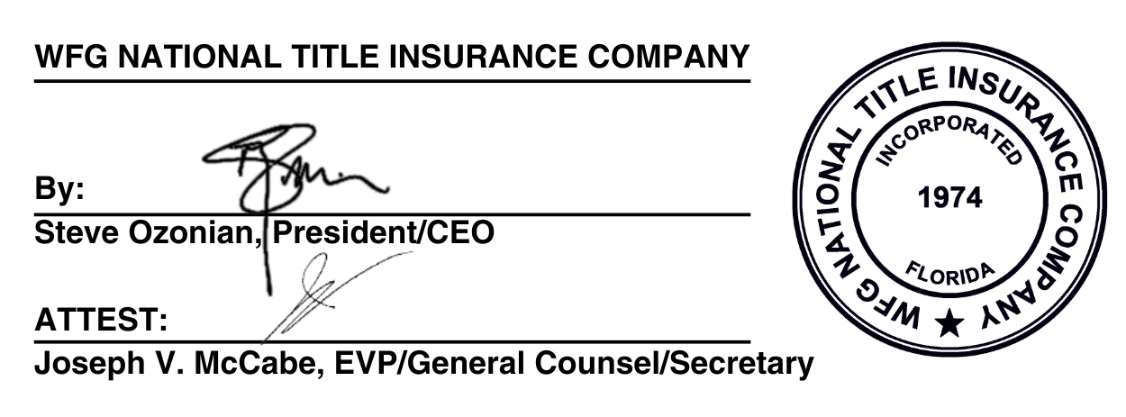

Agent Name

By:
Authorized Signatory

